#51 Lamont Street Longdenville Constructive Avenue Chaguanas

PHONE #: 701-6956/ 391-8112

**ELZO DARIO HAMILTON**

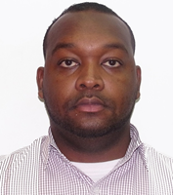

**OBJECTIVE:**

To achieve personal and organization development by being a team player, I am very organized, efficient, extremely competent, and has an excellent rapport with people of all ages. My communication skills, both written and verbal, are excellent.

**PERSONAL INFORMATION:**

* Date of Birth- 6th May 1987
* Marital Status- Single
* Nationality- Trinidadian
* Language – English

**WORK EXPERIENCE:**

Year-2008 to Present

* I am currently employed at the Public Transport Service Corporation.
* I have gained numerous experiences in the Administrative field.
* Currently doing studies in Project Management (CTS) - 2017.

**EDUCATION:**

YEAR:

999-2002 Chaguanas Junior Secondary School -14+ Exams

2002-2004 Carapichaima Senior Comprehensive -NEC Examinations

2008 - (CTS) – Computer Literacy

2017- Project Plus Project Management

**REFERENCES:**

* Giselle Boodhoo –Main Road Longdenville - 736-0327
* Brendon Francios – Longdenville – 315-1105